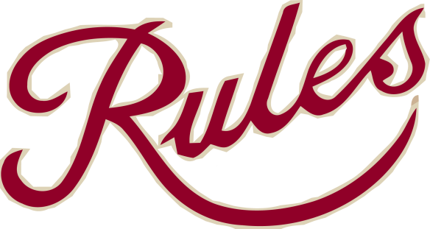

Burns Night at Rules Restaurant

Sunday, 25th January 2015
From 6 pm

£45.00 for three courses
£52.50 for three courses and a dram of Naked Grouse

Venison Carpaccio
~
Haggis, Neeps and Tatties
~
Chocolate Whisky Mousse

For reservations call 020 7836 5314 or email info@rules.co.uk

